Project Design Phase
Solution Architecture

Date | 14 October 2026
Team ID | ----------------------------
Project Name | Car Rental Request Automation in ServiceNow Using Service Catalog and Workflows
Maximum Marks | 4 Marks

Solution Architecture:
Solution architecture is a complex process – with many sub-processes – that bridges the gap between business problems and technology solutions. Its goals are to:
- Find the best tech solution to solve existing business problems.
- Describe the structure, characteristics, behavior, and other aspects of the software to project stakeholders.
- Define features, development phases, and solution requirements.
- Provide specifications according to which the solution is defined, managed, and delivered.

Solution Architecture Diagram:

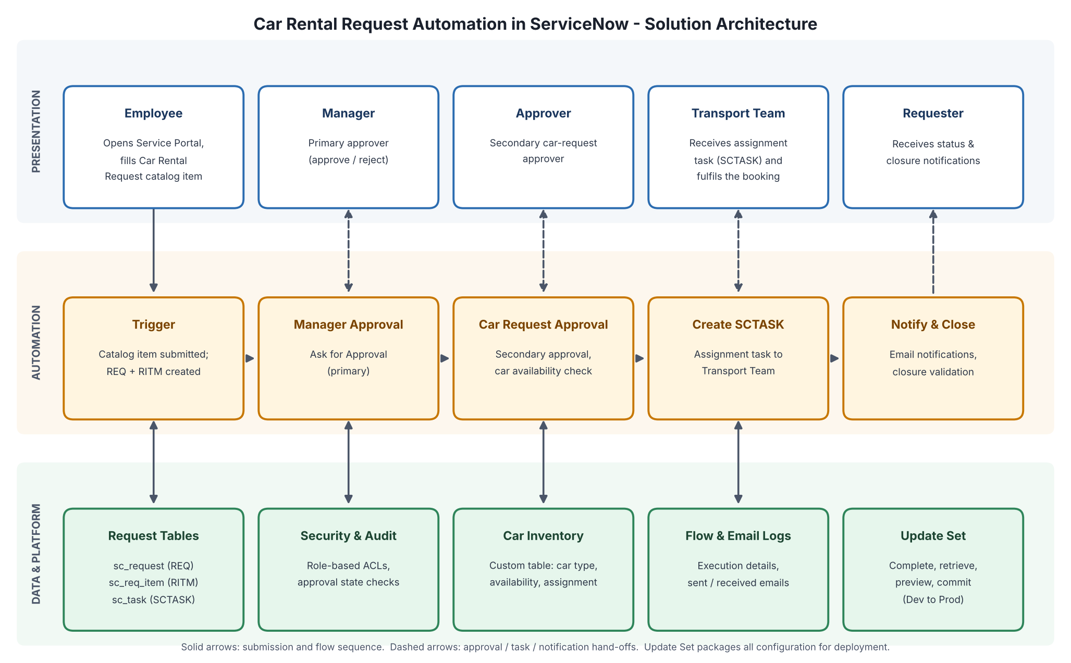
Figure 1: Architecture and data flow of the Car Rental Request Automation in ServiceNow
Reference: ServiceNow Product Documentation – Service Catalog and Flow Designer (https://docs.servicenow.com)

Architecture Overview:
The solution has three layers. The presentation layer is the Service Portal and Service Catalog, where employees submit requests and managers, approvers and the transport team act on them. The automation layer is a Flow Designer flow supported by Business Rules, which routes approvals, validates car availability, creates tasks and sends notifications. The data and platform layer holds the request tables, car inventory, security rules and the Update Set used for deployment.

Key Components:
• Catalog Item – Car Rental Request: variables Requested Date, Pickup Location, Drop Location, Duration, Car Type and Reason, with client scripts for mandatory-field and auto-fill validation.
• Flow Designer: triggered on catalog submission; runs Manager Approval (primary), Car Request Approval (secondary), availability check, SCTASK creation, notifications and closure validation.
• Business Rules: auto-assign tasks to the Transport Team, update request status after approvals and send notifications on completion.
• Data Tables: sc_request (REQ), sc_req_item (RITM), sc_task (SCTASK), sysapproval_approver for decision history, and a Car Inventory table (or external data source) for car availability and assignment.
• Security: role-based access for requesters, managers, approvers, transport team and admins; approval-state enforcement; audit logging of requests, approvals and notifications.
• Deployment: all configuration is tracked in an Update Set, set to Complete, retrieved in the target instance, previewed and committed.

Data Flow:
1) The employee submits the catalog item and the REQ and RITM records are created. 2) The flow sends the request to the manager for approval. 3) After approval, the secondary car request approval runs and car availability is checked. 4) An SCTASK is created and assigned to the Transport Team. 5) Notifications are sent at each stage and the request is closed after fulfillment validation.

Technology Stack:
ServiceNow instance (admin access), Service Catalog, Service Portal, Flow Designer / Workflow Engine, Business Rules, Client Scripts, Script Includes, Notifications and Update Sets.

